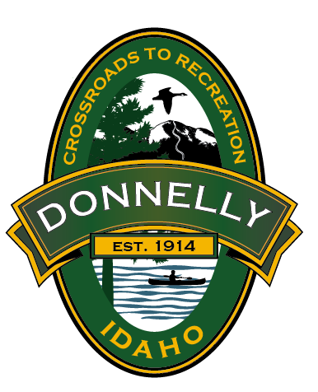 **City of Donnelly**

169 Halferty Street

P.O. Box 725

Donnelly, ID 83615

Telephone (208) 325-8859 Fax (208) 325-4091

Job Title: **Campground Host Volunteer**

Job Summary:

The ideal volunteer campground host will live in the campground and will be willing to perform a multitude of tasks such as greeting visitors, collecting fees, light maintenance duties, and informing city staff of potential problems.

Work Schedule:

Campground hosts work a minimum of 21 hours per week (including weekends and holidays) for a minimum of 30 days, starting May 31st not to exceed staying past September 29th, which is when the City will close the campground for the season.

Benefits to Volunteering at City of Donnelly Campground:

* Free campsite equipped with water, electricity, and sewer hook-ups with a beautiful view
* Complete Orientation and Job Training
* Close proximity to fishing and other recreational summer activities
* Uniform Provided

Job Duties: (this is a general list of tasks to be performed, the amount of time spent for each task will vary depending on how full the campground is/how much it’s been used.)

* Greet park visitors
* Answer questions about the campground and general surrounding area
* Perform campground walk-through twice a day
* Inform park visitors of campground rules and regulations
* Notify City staff if enforcement action is needed
* Check restrooms
* Clean restrooms
* Restock paper supplies
* Remove litter/trash by disposing into our garbage cans to be dumped weekly
* Weed/trim shrubs as needed/remove trash from fire rings

Fee Collection:

* Ensure that park visitors have camp fee envelopes displayed in a visible spot and that the dates on the envelope match the dates that they are staying
* Also ensure that park visitors are paying for the number of vehicles in their camp sites

Emergency Operations:

* If in the even that City staff aren’t available, take appropriate action during visitor or maintenance emergencies:

-Identify Problems

-Notify appropriate authorities of emergencies

* Share storm warning information with park visitors